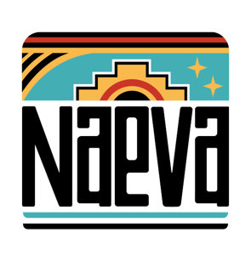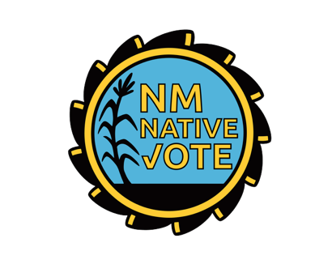

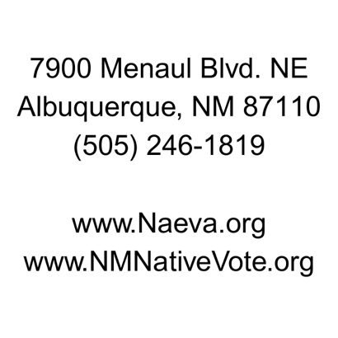

WE’RE HIRING AN

INDIGENOUS ENERGY ORGANIZER
NAEVA AND NM NATIVE VOTE (NMNV) ARE INDIGENOUS-LED NON-PROFIT ORGANIZATIONS BASED IN ALBUQUERQUE AND FARMINGTON, NEW MEXICO. Rooted in the defense of sacred ancestral Pueblo lands, our mission has grown to encompass building educational, economic, and political power across the 24 Tribes, Nations, and Pueblos in New Mexico, as well as in urban Native communities. Through community organizing, policy advocacy, and civic engagement, we uplift Indigenous working families, protect our environment, and inform our communities on the issues that impact our cultures, lands, and futures.
We are seeking an eager professional to join us as an Indigenous Energy Organizer (IEO) who will work with the Farmington Indigenous Energy team to promote the objectives of clean energy work in the 4 Corners region. They will be expected to analyze energy policies and current events to ensure Diné communities are included in an equitable and just transition. The IEO will engage community stakeholders in Dinétah to inform them of current and upcoming energy policy, build out a reliable membership base, and coordinate with the Indigenous Energy Team to mobilize communities to fight for policies that benefit our communities, and protect our air, land and water. Our ideal candidate will be energetic, creative, skilled in coalition building, and able to deal with complex subjects with diplomacy and candor.
The IEO position reports to the Indigenous Energy Team Manager and CEO and will be working in partnership with other staff to accomplish programmatic efforts.
IN YOUR ROLE as our Indigenous Energy Organizer, you will:
Work collaboratively with the Indigenous Energy Team in the 4 Corners area and Albuquerque areas
Support civic engagement table efforts, including Get Out the Vote campaigns
Participate in all staff meetings and work independently
Engage and educate community members and partners in community spaces
Establish and build a membership base in the 4 Corners area
Support with the Naeva Navajo Nation Advisory Council
Provide media statements as needed
Support and implement education campaigns
Build relationships with tribal leaders and community members
Provide technical assistance and education back to community
Attend Navajo Nation Council, chapter house meetings and NM legislative session
Report back on any community campaign or partnership

WE NEED SOMEONE WE CAN COUNT ON. Our Indigenous Energy Organizer should have:
Associate or Bachelor’s degree preferred
1-3 years of related experience and/or training, or equivalent combinations of education and experience
Must have a valid Driver’s License, reliable transportation, and pass a background check
Proficiency in data collection. Creating and submitting digital documents, along with reporting
Knowledge of or willingness to learn energy-related policy and organizing strategies
Experience in creating publicity in print, digital, and social media
Working knowledge of Microsoft Office suite and related software
Strong interpersonal and research skills, with a desire to continually learn
Ability to perform well in a stressful environment
Excellent verbal and written communication skills
Open to proficiency in Diné language, whether verbal or written (highly desired)

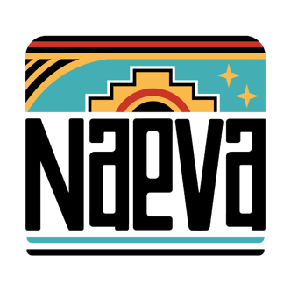

POSITION DETAILS:
The IEO will be required to work in person at our office in Farmington, NM. Travel to Main Naeva Office in Albuquerque, and Santa Fe during the NM Legislative Session will be required. Occasional travel throughout New Mexico and the U.S. for educational conferences or programmatic events.
This position is full-time, salaried, and exempt. Salary is $55,000 per year based on experience, with benefits including medical/dental/vision, paid vacation, sick, or personal days, and an annual professional development, self-care, or tuition reimbursement
HOW TO APPLY:
Send resume and a cover letter to tyla@naeva.org with the subject "Indigenous Energy Organizer Application." Cover letter should include what experience and skills you bring, why this is important work to you, who you consider your community, and please include 3 references.
Naeva and NM Native Vote are equal opportunity employers that do not discriminate in their hiring practices and aim to build the strongest possible workforce, actively seeking applicants of varying life experiences, cultures, identities, geographies, abilities, and racial/ethnic backgrounds. Indigenous, two-spirit, BIPOC, LGBTQ+, and women are strongly encouraged to apply.

